Your Wastewater Treatment plant is equipped with an audible and visual alarm state codes require this device be equipped on your septic system.
Alarm Box
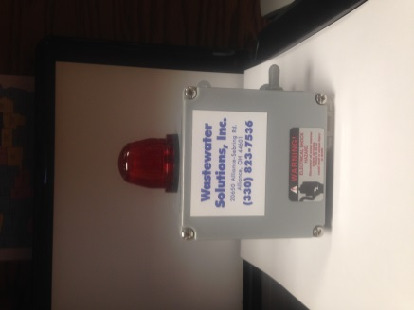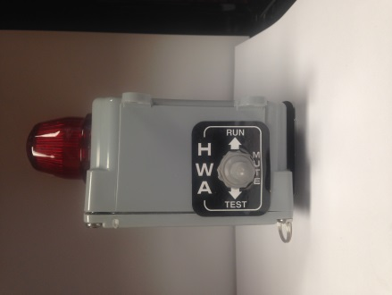
Front view Side view
What to do if your Septic System alarm goes off:
- Don’t panic, sometimes alarms go off indicating some type of service is needed. Note: very rarely do alarms go off because they need pumped.
- Go to were the alarm is sounding from, you should see the red alarm illuminated, this light is situated on top of the gray electrical box as shown above, pull the gray toggle switch to the middle position marked mute ,this will silence your alarm but the red light will remain lit until serviced.
- Please call the number on your alarm box or your local service provider and report your alarm to the office, if closed leave a message indicating your name, address and phone number and someone will get back to you within 48 hours.
- Your light will remain lit until serviced; you can still use water however don’t use water unnecessarily, meaning laundry, full bath tubs, etc.
- If you recently pumped out your system the alarm will go off indicting there is low water level in the aeration tank, this is normal due to a pressure switch within the control panel, once the Aeration tank which is the one with the alarm on top, is three quarters full of water the alarm and light will turn off. If your pumper has not put the toggle switch on mute, you may want to do so.
- It is recommended in the pumping instructions to fill the system with fresh water after pumping which will eliminate this from occurring.

